EDITH CAVELL SURGERY

Patient Participation Group (PPG) Meeting

Date: Wednesday 2nd August 2023
Staff Present: RM, BB, RD, Joined by Research Pharmacist and Research Communications Manager
Patients Present: HR, JG, PS, CK, HK, CA, EQ,

Staff Apologies: Dr SZ
Patient Apologies: FJ, MVS
Agenda item | Discussion | Action | Status
Welcome and Introductions
Increasing BAME Participation in Research Studies | Mo, Judith and Bethan joined the PPG meeting to get some ideas from PPG members about how to increase patient participation in Research Studies, especially patients within the BAME community.  Members shared some of their experience in participating in research studies, especially during the COVID pandemic.  With regards to increasing participation in particular communities, some ideas suggested included:  - Patients being more likely to trust a study if recommended by the GP, so researchers could consider the GP as a way to inform patients of studies  - Incentives are not always the main reason why people participate (e.g. some patients are motivated by the idea of participating in meaningful research or a cause close to their heart). However, incentives are still helpful.  - Transparency around who is conducting the research, what will be done with the data and who has access to it.  - Opportunistic pop-ups in health care centres (e.g. having a stall at Gracefield Gardens Healthcare centre).  - Involving faith groups and community leaders can be helpful  - Patients can understandably be sceptical about the legitimacy of text message invites to participate in studies, they may worry that the text messages are a scam. Similarly, email invites may end up in junk mail.  - Online and Social Media can be another way to advertise research studies (e.g. Facebook). | - A questionnaire about patient experiences of research studies was handed out during the meeting. For any members that joined via Zoom, or any patients that would like to fill out the questionnaire it can be shared with them via email. | - Done
Previous Meeting Minutes | - SELDOC: It was discussed that, following last PPG meeting, 111 confirmed that they are the first point of contact after hours and that they can refer onwards to SELDOC if required. PPG members commented that they found SELDOC to be a very useful service in the past so they are glad that it still exists, however, they preferred being able to contact SELDOC directly instead of via 111. A PPG member suggested that each borough should have a HealthWatch that this type of feedback can be forwarded on to; with enough patient feedback the NHS may consider reinstating a direct contact number for SELDOC.  - Dr iQ Closing Message: PPG Members mentioned that although the Dr iQ out of hours message has improved, there is a misleading sentence suggesting that “online consultations” can be submitted 7 days a week. This wording could mislead patients into thinking that they can raise medical issues at any time of day, when in fact the only sections in Online Consultation that are still accessible after hours is Enter Health Data (e.g. BP, weight, height), Order Medication, or Chase up a Referral – these are actioned when the surgery opens again.  - Scam Texts: If the practice is made aware of our patients receiving any scam texts in the future, the practice can ask the Communication Team to post an alert on any social media accounts linked to the practice (as well as sending a text around to let patients know).  - Patient Data: Practice explained that because Edith Cavell Surgery is a Safe Surgery (for vulnerable patients or refugees who may not yet have identification documents) we have decided against requiring all patients to present ID to update their address. However, we may still ask for ID on certain occasions, when necessary. Going forwards the admin team will write an entry into patients’ records when updating their address. The entry will confirm name of staff amending address, date/time, previous address and it will state that the relevant security questions were asked to confirm patient’s identity. The PPG members explained that whilst this is useful, the potential consequences of any accidental changes to patients’ addresses could be very serious, and so additional safeguards should be in place. The PPG members suggested, for example, that the practice could submit a new feature request to the providers of their clinical system asking for them to develop a feature that automatically notifies the patient when their address is changed. “If you did not request a change of address please contact your surgery to let them know”.  - Call-Back Feature: Patients now have the option of keeping their place in the queue and hanging up, and the phone system will automatically call the patient back once they reach number 1 in the queue. If they do not pick up the first time, the phone system will try them again once more after a few minutes. Some PPG members did not know that this feature had been released 2-3 months ago. Therefore, the PPG members would like to know what makes the call-back feature kick in: Is it when there is a high volume of calls coming in, or is it when there is a long waiting time irrespective of how many calls are in the queue. | - SELDOC: Practice to find out the relevant organisation to feedback to that some of our patients found it more helpful being able to contact SELDOC directly.  - Dr iQ Closing Message: Practice to amend closing message  - Patient Data: The practice agrees on the importance of ensuring all updates to patient data are accurate. They will therefore submit a request for this feature to be considered for future updates to our clinical system.  - Call-Back Feature: Practice to find out what makes Call-Back feature kick in, is it volume of calls or average waiting time? | - SELDOC: Done. Feedback sent to SEL ICB (South East London Integrated Care Board)  - Dr iQ Closing Message: Dr iQ Closing messages are no longer managed in the surgery, they are managed by the Comms team. Request sent to Comms team and they confirmed they will consider our new closing message recommendations.  - Patient Data: New Feature Request submitted to the provider of our clinical system.  - Call- Back Feature: Done, The Call back feature is activated automatically when there are at least 5 patients queuing, regardless of waiting time.
How has the Telephone Appointment booking been working? | A PPG member wanted the surgery to provide an update on how the telephone appointment booking system has been working (i.e. Patients having to call at 8am).  - At 8am we have appointments released on the day. We also have appointments released up to 2 weeks in advance. From a practice point of view, having this mixture of on the day and advance bookings seems to be working well.  - A PPG member explained that they have still been having difficulties booking appointments because when they call they often find themselves having to queue to get through. It was advised that the new Call-Back phone feature should help with this as many patients have reported having positive experiences receiving an automatic call back from the surgery instead of having to stay on the phone. Another alternative to calling at 8am is coming into the practice at 8am to book appointments. The PPG member confirmed that this has sometimes worked better for them. | - Decreasing Volume of Calls: For patients with access to a smartphone, the practice is continuing to provide as much support as necessary to increase their confidence in using their Dr iQ app for appointment bookings, requesting sick notes and medications, chasing up referrals and providing health data readings (BP, weight, height). Increasing the number of patients actively using our digital services leads to a decrease in phone waiting times for housebound patients or patients who prefer to access their surgery via telephone.  - Lambeth Digital Champion: For patients with access to a smartphone who only feel confident using their phone to call and text, Edith Cavell is signed up to the Lambeth Digital Champion service. This service allows our receptionists to make referrals to 'Lambeth Digital Champions’ who support patients with setting up their emails, signing up to healthcare apps like Dr iQ, and learning how to browse the internet. | NA
Recent Secondary Care Strikes and long hospital waiting lists – what impact have these had on GP? | - The impact of strikes and long hospital waiting lists on GPs is difficult for us to measure because, once the patient sees the GP and we refer, the hospital oversees their own waiting times and they prioritise patients according to their own criteria. Only in exceptional circumstances are we made aware in advance that a particular service is experiencing severe backlogs - in those cases our GPs suggest alternative hospitals/services to patients where appropriate.  - Other than these exceptional circumstances, the surgery usually only becomes aware that a patient is still awaiting an appointment when the patient informs the admin team that they have not heard back from their referral, or when the patient books a follow up appointment if their symptoms have persisted or worsened whilst awaiting a referral. In these cases, a GP can sometimes send a further letter to the hospital asking them to expedite the patient’s case so that the hospital sees the patient sooner.  - Whilst the GP is not typically able to gather data on the impact of strikes, NHS Digital (the government organisation tasked with collecting and studying this type of data) will undoubtedly be keeping a close eye on the impact of strikes on waiting lists and GP demand, and they will continue to advise GP surgeries accordingly.  - SEL ICB (South East London Integrated Care Board), the NHS organisation that oversees healthcare for South East London, helpfully update us on what support is available for hospitals and general practice when strike days are announced. For example, they will let our GPs know when a strike results in reduced capacity at walk-in x-ray departments, or when emergency services are particularly strained. | NA | NA
GP Surgery Winter Planning | - Medical Assistants will be supporting with administering flu vaccinations during the winter season.  - Only those deemed as being ‘At Risk’ will be invited in for a free flu vaccine at the GP surgery. For those not eligible for a free vaccine, pharmacies will be running their usual paid-for flu jab clinics.  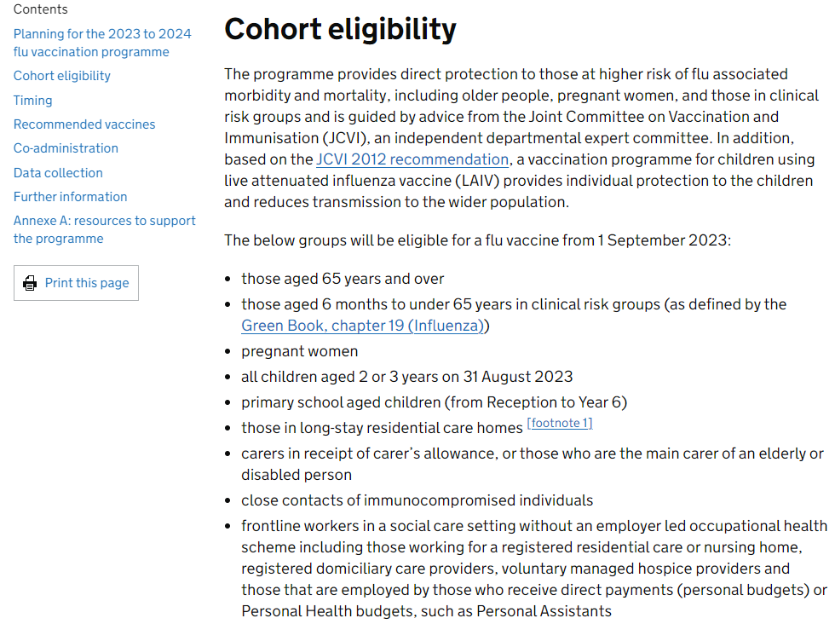 | NA | - Who is “At Risk”?: The UK Government website on the National Flu Vaccination Programme for 2023-2024 (attached) provides information on which cohorts are eligible for a free winter flu vaccine
DNA statistics for 2023 | - There has been a decrease in DNAs from 5.6% of appointments in first quarter of the year, to 5.4% of appointments in second quarter. This means a reduction in roughly 150 DNAs in the second quarter of the year.  - The practice has a new text appointment reminder system that should help to minimise DNAs in the long run, but as it is a new service we are currently working to iron out any initial problems. This may mean that Quarter 3 has a slight increase in the number of DNAs whilst we are resolving any issues with the new system.  - Once issues have been resolved, the practice will revert to sending warnings to patients who do not inform us when they cannot attending their appointments. | - Practice to attach DNA statistics when sending meeting minutes | - Done, DNA statistics attached to minutes email.
Basic Life Support Training for admin team in October | - Staff training on Basic Life Support will be taking place in October. This helps our admin team feel more confident they will be able to respond safely, quickly and appropriately to any future emergencies.  - The admin team also recently participated in a mock emergency situation with one of our senior doctors. The doctor created a realistic emergency scenario and monitored how each member of the admin team responded. The doctor also provided useful feedback on any areas that required improvement. | - Practice can comment on how this training went at the next PPG meeting in November 2023. | Pending
Staff Update | - External Physiotherapists will be joining our practice for Mondays, Wednesdays and Fridays. | NA | NA
AOB | - Patient Toilet: Is the patient toilet in reception out of order?  - Appointment Sign-In Screen problems: Some patients are arriving at the wrong site and, because we are the same practice across both sites, they are using the check in screen to arrive themselves for their appointment despite being at the wrong location. This can result if the patient missing their appointment or a clinic running very behind schedule if a clinician agrees to wait for the patient to make their way to the correct site. When booking appointments, the reception team remind patients which site to attend. The new appointment reminder text service will help as it automatically states the correct appointment location.  - Photos of staff in the reception area: Staff photos are out of date and could be arranged to that it is clear who are the GPs, Physician Associates, Nurses, Healthcare Assistants, Management Team, Social Prescribers, Care Coordinators and Receptionists. | - Patient Toilet: Staff to check whether both patient toilets are in good working order.  - Appointment Locations: At the next administrative meeting, reception staff will be reminded to check whether patients knows which site to attend before ending the call.  - Next PPG Meeting scheduled for 8th November 2023 | - Patient Toilet: Both staff toilets are in working order, there is a notice on the toilet door, but it is just advising patients not to flush wipes  - Staff Photos: Pending

Patients can join future PPG meetings by sending an email to: lamccg.ecs@nhs.net

