EDITH CAVELL SURGERY

Patient Participation Group (PPG) Meeting

Date: Wednesday 3rd May 2023
Staff Present: Dr SZ, BB, RD, MC
Patients Present: HR, JG, MVS, PA, CK, HK

Staff Apologies: RM
Patient Apologies: RM, FJ, CA
Agenda item | Discussion | Action | Status
Welcome and Introductions
Previous Meeting Minutes | PPG Members would like the minutes to be more detailed so that they more accurately reflect discussions. Members would also like minutes to have a separate section for actions that have been agreed and queries that the practice is going to look into. | - The minutes template has been amended to include a new column for Actions that have been agreed during the meeting.
Phone lines close at 6:30pm | Now that the phone lines close at 6:30pm the PPG members would like confirmation that the “Practice Closed” phone message directs patients to the appropriate Out Of Hours service (e.g. 111, SELDOC, A&E). | - Practice to check “practice closed” voicemail to ensure it signposts appropriately  - Practice to confirm whether SELDOC still has a direct patient number for after 6:30pm, or whether patients should go through 111 in the first instance.  - Practice to check Dr iQ signposts patients appropriately after the app is closed. | - Edith Cavell reviewed the automated message that plays after closing time. The message confirms our opening hours, what to do if you’re calling to cancel your appointment, queries that can still be accessed in Dr IQ (e.g. Test results, medical records, ordering repeat prescription), and it also signposts to 111 for urgent medical attention and 999 for emergency medical attention.  - Practice contacted SELDOC on 5th May 2023 who confirmed that they no longer have a direct contact number for patients. The current protocol for the borough is that after 6:30pm patients must use 111.nhs.uk for all Urgent Medical Advice or for those who may be unable to use the internet they can dial 111. (NHS 111 can then book with SELDOC when appropriate). Edith Cavell Surgery spoke with NHS 111 and they confirmed the same protocol.  - Below is a screenshot of the Out of Hours message displayed in Dr iQ once certain Online Consultation pathways have reached full capacity (please note, the “Reception Desk & Querys” tab remains open 24/7:  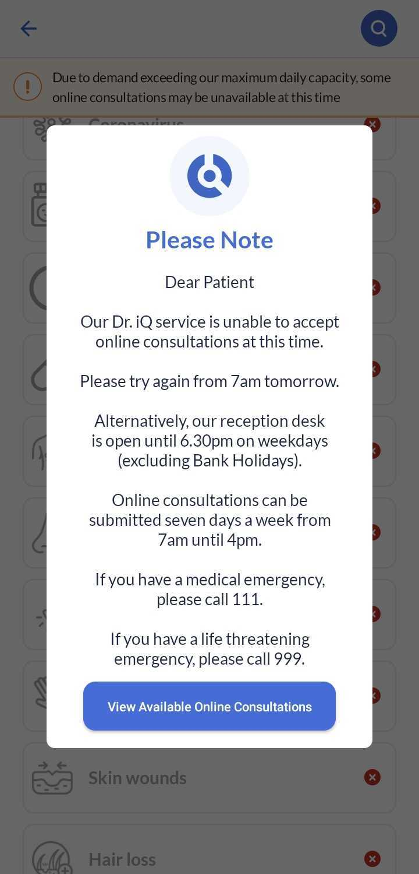
Calls from Central Pharmacy Team | One of the PPG members were receiving multiple calls a week and sometimes multiple calls a day from Edith Cavell Surgery, with the same questions being asked by different people and they felt there was a lack of clarity around what condition/medication was being reviewed and why. The member said they have received at least 11 calls since last PPG meeting 18th Jan 2023. Patient explained that their brother is also receiving similar calls and the central pharmacists that call sometimes suggest/make changes to their medications that they would prefer to discuss with a GP. | - Practice to look into this PPG member’s specific case and call patient back up to share findings. Update PPG generally about the findings. | - Practice has looked into this patient's case and called him back 5th May 2023 to update him on the findings. As this query is regarding reasons for a patient’s appointments the practice was only able to share a detailed explanation of the findings with the patient directly. But, generally speaking, we can confirm that in some cases multiple patients share the same landline which can result in a clinician trying to reach the same number on the same day but for two different patients. Furthermore, because the practice has a policy of calling back a second time if a patient is unable to answer the first call, this can result in a phone receiving 4 missed calls in one day (i.e., 2 patients receiving 2 missed calls each to their shared phone). After a few days the clinicians may try to reach both individual patients again (which could result in a further 4 missed calls).  - In this case, this query has been resolved by adding a note that this patient would prefer to do this particular review with a particular GP they already see regularly, instead of with a clinician from our Central Pharmacist Team.
Post-Appointment Survey Texts | PPG member highlighted that Edith Cavell Surgery’s Post-Appointment Survey texts are sent through MMS (Multimedia Messaging Service) as opposed to SMS (Short Messaging Service). This will be because the text message contains a website link to complete the survey (and as soon as a text message contains a picture or video or website link it becomes a multimedia message instead of a standard text). They were having an issue accessing and responding to these post-appointment survey texts but they were able to resolve it by adjusting a setting to allow their phone to receive MMS text messages. They informed the practice and PPG group in case any patients experience similar problems in the future.  Another PPG member also asked for this agenda item to be discussed as they have difficulties responding to these post appointment survey texts and would prefer to receive these surveys via a different medium. | - The PPG group brainstormed alternative ways to get patient feedback after appointments. For face to face appointments it was suggested that both Edith Cavell sites look into keeping paper versions of the Post Appointment Survey questionnaire at the front desk. | - These post-appointment survey texts were scheduled to come to an end within the coming weeks. Instead of receiving these texts, patients will now receive texts directing them to complete the “Friends and Family Survey” form on our Streatham GP website. This form on our website is more straightforward and accessible.  - For patients without internet access, or who do not feel comfortable using computers/phones, we can confirm that we did used to have paper copies of these Friends and Family surveys that the practice used to keep at reception however these have become noticeably less visible at reception over time and there is not consistency between both sites with regards to offering them to patients and having them accessible. We will therefore implement this again going forward. We will create posters advertising to patients that they can collect Friends And Family Surveys at the reception desk.
Alerting patients to scam text messages | The minutes from the previous meeting stated that if in the future the practice is alerted to any healthcare scam text messages circulating to our patients we should ask our comms team to put a notification on our website. The PPG members explained that whilst this would be helpful, there will be many patients that do not or can not visit our website. The PPG members asked for confirmation that a batch text message would be sent out immediately to all Edith Cavell patients if the practice is made aware of a similar scam text message circulating in the future. | - Edith Cavell Surgery have given their assurances that if they are made aware of a future healthcare text message scam affecting our patients the practice will send a batch text message out to inform all patients as well as asking the comms team to add a warning to the Edith Cavell Surgery website.
Social Prescriber Michaela | Edith Cavell Surgery’s Social Prescriber, Michaela, joined this meeting and explained her role to the members. | - If Michaela comes across any patients that express an interest in joining future PPG meetings, she will advise them to get in contact with us.
Patients’ Data | One of the PPG members explained that after attending a screening at a hospital they were informed that their address had been changed by the GP surgery to an incorrect address. Patient was unaware of this and had not requested this address change. She informed the practice via email and whilst the address was eventually reverted back to the correct address she was concerned at the length of time it took for this to update with other services involved in her care (e.g. pharmacies and hospitals), as well as being concerned that the surgery has been unable to see an explanation for this erroneous address change other than it being a result of human error. The PPG would like Edith Cavell Surgery to explain what steps they are taking to ensure that this does not happen again to any patients going forwards. | - Edith Cavell Surgery apologises for this patient’s experience and shared the concerns that they outlined. It was explained that each amendment in a patient’s record is audited so it is clear when this patient’s address was updated and by whom. Unfortunately what is unclear is the reason why this error happened. As a result, this error has been discussed with the particular member of staff involved and has also been discussed at the monthly administrative team meeting so that staff are extra vigilant when updating contact details.  - It was suggested during the meeting that in order to ensure this does not happen again Edith Cavell Surgery should look into requiring patients to make Address Change requests in person with ID (and in writing or on Dr IQ for those who are unable to come into the surgery).  - PPG Members asked whether Edith Cavell could ask their software provider to add a feature that makes a prompt appear automatically for contact detail changes asking the user to briefly state the reason for amending (e.g. “Patient presented ID at reception and confirmed they have moved to new address”). | - Practice manager agrees that patients should only be able to request address changes in person with ID, or via their Dr IQ app, or via email as long as the email confirms patients name and date of birth. Paper slips will be created and kept at reception for patients to request change of address, these will then be scanned into patients records so that we have a clear audit trail.  - Practice manager confirmed that having the paper slips requests that are scanned into patients records is something that can be implemented immediately so is more feasible than requesting software changes from our provider (our provided maintains the software for the majority of GP surgeries across the whole of the UK). We will therefore trial requesting ID at the front desk first.
DNA statistics for 2023 | This Item will be rolled over to the next PPG Meeting.  However, between 18th January 2023 to 17th February 2023 6% of appointments (421) were DNAs (the patient did not attend and did not cancel).  Between 18th February 2023 to 17th March 6% of appointments (381) were DNAs.  Between 18th March 2023 to 16th April 2023 6% of appointments were DNAs (304).  The majority of DNAs from January to April seemed to take place between 8am – 12pm Monday to Thursday. These morning appointment times coincide with the appointments that are pre-bookable in advance by patients.  A PPG member suggested that the longer telephone waiting times in the morning (when the majority of patients call to book a same day appointment) may also dissuade patients from waiting in the phone queue to cancel their appointment. | - Text message reminders are currently sent automatically when the patient books an appointment and a second reminder is also sent 1 working day before the appointment. The text message includes the date, time and location of appointment. The text contains a link that allows patients to cancel their appointment, if they are unable to follow the link the patient can give us a call, or let us know via their Dr IQ app.  - A PPG member suggested that the practice could consider extra reminders for those morning appointment times that tend to have the highest number of DNAs because those appointments may have been booked a week or two ago.  - PPG Members are happy that the practice is continuing to issue warnings to patients who repeatedly DNA, as well as the zero tolerance for over 3 DNAs in the space of a year (taking into account whether patient or family is vulnerable).  - This item will be listed for discussion again in the next PPG meeting as a technical difficulty towards the end of the meeting meant that not all members of the PPG were able to hear or participate in the meeting via Zoom. | - The practice has emailed our Dr IQ support team to ask whether their programming team could add a specific pathway for patients to type in that they want to cancel their appointment at any time of the date.  - Edith Cavell will query with the Regional Manager whether our practice can send a bulk text message out to patients stating that there have been a high number of DNA appointments this year (could briefly include numbers for recent months) and the text can also state all the ways patients can inform us that they would like to cancel their appointment.
New Call-Buster feature on our phone lines | Due to technical difficulty, this item has been postponed until next PPG meeting | - This item will be listed for discussion again in the next PPG meeting as a technical difficulty towards the end of the meeting meant that not all members of the PPG were able to hear or participate in the meeting via Zoom. | NA
Staff Update | New GP, Dr Lunn, will be joining us working predominantly at the Streatham Hill site. She will be doing Tuesdays, Thursdays and Fridays. | NA
AOB | NA | NA

Patients can join future PPG meetings by sending an email to: lamccg.ecs@nhs.net

